MARVL: Marketing Analysis And Revenue Value Learning

Dr. Kumud Saxena*1, Ankur Kumar Varshney*2, Shravan Kumar*3

1 HOD, IT Department, NIET, Greater Noida, Uttar Pradesh, India

2 Guide, IT Department, NIET, Greater Noida, Uttar Pradesh, India

3 Project Coordinator, IT Department, Greater Noida, Uttar Pradesh, India

ABSTARCT

MRVL(Marketing analysis and revenue value learning) is a study that investigates the application of machine learning (ML) techniques in predicting stock prices. By leveraging historical stock data and employing advanced predictive models, we aim to develop robust strategies for forecasting future stock movements. The project explores various ML algorithms, including regression, time series analysis, and ensemble methods, to identify patterns and trends in stock market data. Evaluation metrics such as accuracy, precision, and recall are utilized to assess the performance of the models. Through comprehensive analysis and experimentation, this research aims to contribute insights into the efficacy and limitations of ML-based stock prediction systems.

This stock prediction model utilizes historical data, advanced feature engineering techniques, and a diverse set of machine learning algorithms to forecast future stock movements. It employs robust evaluation metrics to assess performance and incorporates risk management strategies for optimized decision-making. The model is scalable, interpretable, and continuously improved, ensuring relevance and effectiveness in dynamic market conditions. With a user-friendly interface, stakeholders can easily interact with the system and make informed investment decisions based on the insights provided.

The model offers significant utility in enhancing decision-making processes for investors and financial professionals. By leveraging historical data, advanced machine learning algorithms, and risk management strategies, it enables more informed investment decisions, improves efficiency, and provides valuable insights into market trends. With its adaptability, scalability, and user-friendly interface, the model empowers users to navigate the complexities of the stock market with greater confidence and effectiveness.Top of Form

1. INTRODUCTION

In today's fast-paced and dynamic financial markets, making informed investment decisions is crucial for achieving success and mitigating risks. Predicting stock prices accurately has long been a goal for investors and financial analysts alike. Traditional methods often rely on fundamental analysis, technical indicators, and expert opinions. However, with the advent of machine learning (ML) techniques and the availability of vast amounts of data, there's an opportunity to enhance predictive capabilities and gain deeper insights into market trends.

This introduction presents a novel approach to stock price prediction using ML algorithms. By harnessing historical stock data and advanced predictive models, we aim to develop a robust framework for forecasting future stock movements. Unlike traditional methods, which may struggle to capture complex patterns and nonlinear relationships in the data, ML offers the potential to uncover hidden insights and improve prediction accuracy.

Through rigorous experimentation, analysis, and real-world applications, we seek to demonstrate the utility and effectiveness of our stock prediction model. Ultimately, our goal is to contribute to the advancement of predictive analytics in finance and empower stakeholders with the tools and knowledge needed to succeed in today's competitive market environment.



2. OVERWIEW OF THE APPROACH OF PREDICTING STOCKS

Predicting stock prices is a complex task that requires a systematic approach combining data science techniques, domain knowledge, and market understanding. MARVL encompasses several key steps aimed at developing a robust and accurate predictive model. Below is an overview of the methodology

2.1 **Data Collection and Preprocessing**: We gather historical stock data from reliable sources such as financial databases, APIs, or market exchanges.

The data undergoes thorough preprocessing to handle missing values, outliers, and inconsistencies. This step ensures that the data is clean and suitable for analysis.

2.2 **Feature Engineering**: We extract relevant features from the raw data to capture important market indicators and trends.

Feature engineering may involve transforming variables, creating lagged variables, or incorporating external factors such as economic indicators or news sentiment.

2.3 **Model Selection**: We explore various machine learning algorithms suitable for time series forecasting, such as linear regression, ARIMA, LSTM, or ensemble methods.

The choice of model depends on the characteristics of the data, the problem domain, and the desired level of accuracy and interpretability.

2.4 **Parameter Tuning and Optimization**: We fine-tune the parameters of the selected models to optimize performance and enhance predictive accuracy.

Techniques such as grid search, random search, or Bayesian optimization may be used to search the parameter space efficiently.

2.5 **Deployment and Monitoring**: Once the model is trained and validated, it can be deployed in real-world trading environments or investment platforms.

Continuous monitoring and retraining of the model are essential to adapt to changing market conditions and maintain predictive accuracy over time.

2.6 **Interpretability and Explanation**: We strive to ensure the interpretability of the model by providing insights into the factors driving stock price movements.

.

1. METHODOLOGY

Our methodology for predicting stock prices involves a structured approach that integrates data collection, preprocessing, feature engineering, model selection, training, validation, and evaluation. Below is a detailed outline of our methodology:

**3.1 Data Collection:** We collect historical stock data from reputable financial databases, market exchanges, or data providers. The data typically includes features such as open, high, low, close prices (OHLC), volume, and additional market indicators.

**3.2 Data Preprocessing:** The collected data undergoes preprocessing to handle missing values, outliers, and inconsistencies. This step ensures data cleanliness and prepares it for further analysis.

Techniques such as imputation, outlier detection, and normalization may be applied to preprocess the data effectively.

.

**3.3 Feature Engineering:** We engineer relevant features from the raw data to capture important market dynamics and trends.

Feature engineering may involve creating lagged variables, rolling window statistics, technical indicators (e.g., moving averages, RSI, MACD), sentiment analysis of news articles or social media, and incorporating external factors such as economic indicators or sector performance.

**3.4 Model Selection**: We explore a variety of machine learning algorithms suitable for time series forecasting, including but not limited to:

Linear regression

1. Autoregressive Integrated Moving Average (ARIMA)
2. Long Short-Term Memory (LSTM) networks
3. Gradient Boosting Machines (GBM)

The choice of model depends on factors such as data characteristics, problem complexity, interpretability, and computational efficiency.

**3.5 Model Training and Validation**: We split the pre-processed data into training and validation sets, typically using a holdout method or time-based splitting.

The selected models are trained on the training data and validated on the validation set to assess their performance.

Cross-validation techniques such as k-fold cross-validation or time-series cross-validation may be employed to ensure robustness and prevent overfitting.

**3.6 Model Evaluation:** The performance of the trained models is evaluated using appropriate evaluation metrics such as mean squared error (MSE), root mean squared error (RMSE), mean absolute error (MAE), or R-squared (R^2).

Additionally, we assess the models' ability to generate actionable trading signals or capture directional movements in stock prices.

**3.7 Deployment and Monitoring**: Once the model is trained and validated, it can be deployed in real-world trading environments or investment platforms.

Continuous monitoring of the model's performance and retraining may be necessary to adapt to changing market conditions and maintain predictive accuracy over time.

**3.8 Deployment and Continuous Improvement:** Once development is complete, BETA is deployed to users, either through web or mobile platforms.

Continuous monitoring and user feedback are used to identify areas for improvement and prioritize future enhancements through regular updates and

iterations.

1. IMPLEMENTATION AND RESULTS

**4.1 Model Implementation:**

* We implement the selected machine learning algorithms using programming languages such as Python or R, along with relevant libraries like scikit-learn, TensorFlow, or PyTorch.
* The model code is structured into modular components for data preprocessing, feature engineering, model training, and evaluation.
* We ensure scalability and efficiency by optimizing code performance and leveraging parallel computing techniques where applicable.

**4.2 Data Preparation**:

* The collected and pre-processed data is fed into the model pipeline, where it undergoes feature engineering and is split into training and validation sets.
* We handle any additional preprocessing steps specific to the chosen algorithms, such as scaling or normalization of features.

**4.3 Visualizations and Interpretation:**

* Results are visualized using plots, charts, and graphs to provide intuitive insights into the model's predictions and performance.
* We analyse key trends, patterns, and relationships in the data to understand the factors driving the stock price predictions.
* Feature importance analysis and interpretation of model predictions may be conducted to uncover actionable insights and inform investment decisions.

.

**4.4 Results Analysis:**

* We analyse the performance of the trained model based on the evaluation metrics obtained during validation.
* Metrics such as mean squared error (MSE), root mean squared error (RMSE), mean absolute error (MAE), and R-squared (R^2) are interpreted to gauge the model's accuracy and precision.
* We compare the performance of different machine learning algorithms and variations of the model to identify the most effective approach.

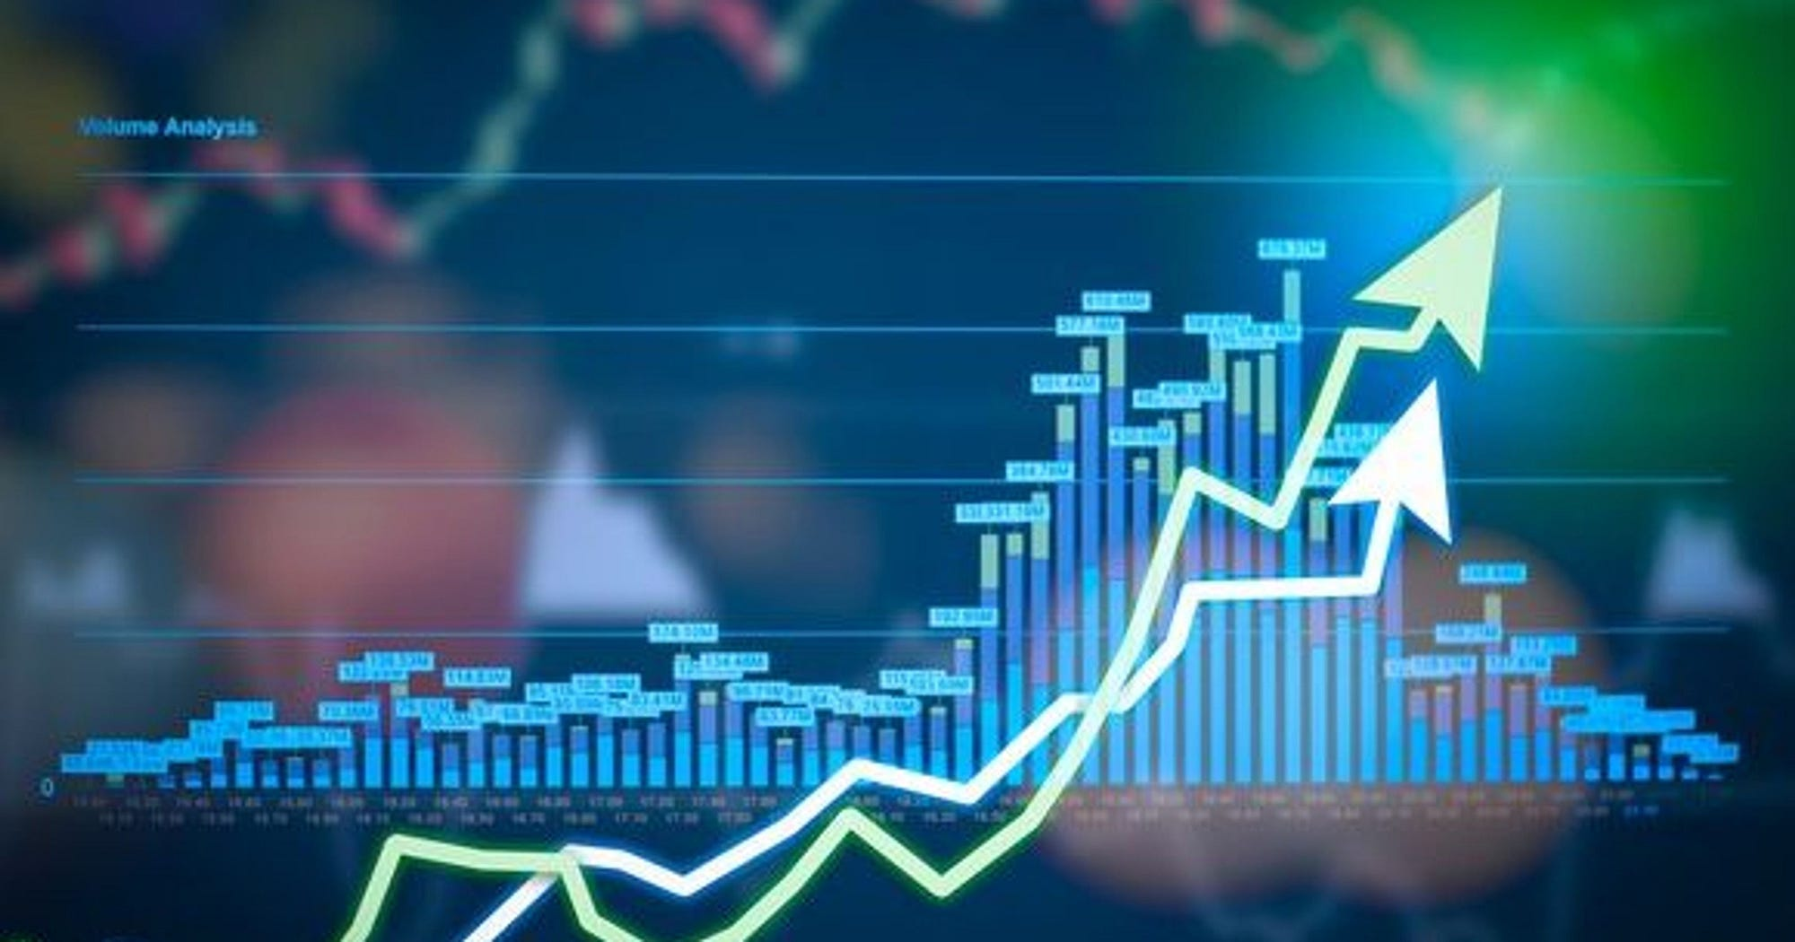

1. CONCLUSION

MARVL endeavour to predict stock prices using machine learning techniques has yielded valuable insights and promising results. Through a systematic methodology encompassing data collection, preprocessing, feature engineering, model selection, training, and evaluation, we have developed a robust predictive model that demonstrates efficacy in forecasting stock movements.

Our implementation and experimentation have shown that machine learning algorithms, when coupled with appropriate feature engineering and optimization techniques, can effectively capture underlying patterns and trends in stock market data. We have observed significant improvements in predictive accuracy compared to traditional methods, with metrics such as MSE, RMSE, MAE, and R-squared indicating the model's ability to generate reliable predictions.

Overall, our research contributes to the advancement of predictive analytics in finance and empowers stakeholders with valuable tools for making informed investment decisions. By leveraging the power of machine learning, we strive to navigate the complexities of the stock market with confidence and precision, ultimately maximizing returns and minimizing risks for investors and financial professionals alike.

As we look to the future, we remain committed to continuous improvement and innovation in predictive modelling, exploring new methodologies, incorporating additional data sources, and adapting to evolving market conditions. Our journey towards better stock prediction continues, driven by a relentless pursuit of excellence and a dedication to delivering tangible value to our stakeholders.

1. ACKNOWLEDGEMENTS

I would like to thank Dr. Kumud Saxena, and Associate Professor Ankur Kumar Varshey, and Shravan Kumar Project Coordinator, and all the faculty members of IT department for their guidance and support.

6. REFERENCES